VMWare installation and Windows installation
Collin King
201 Commercial client op systems
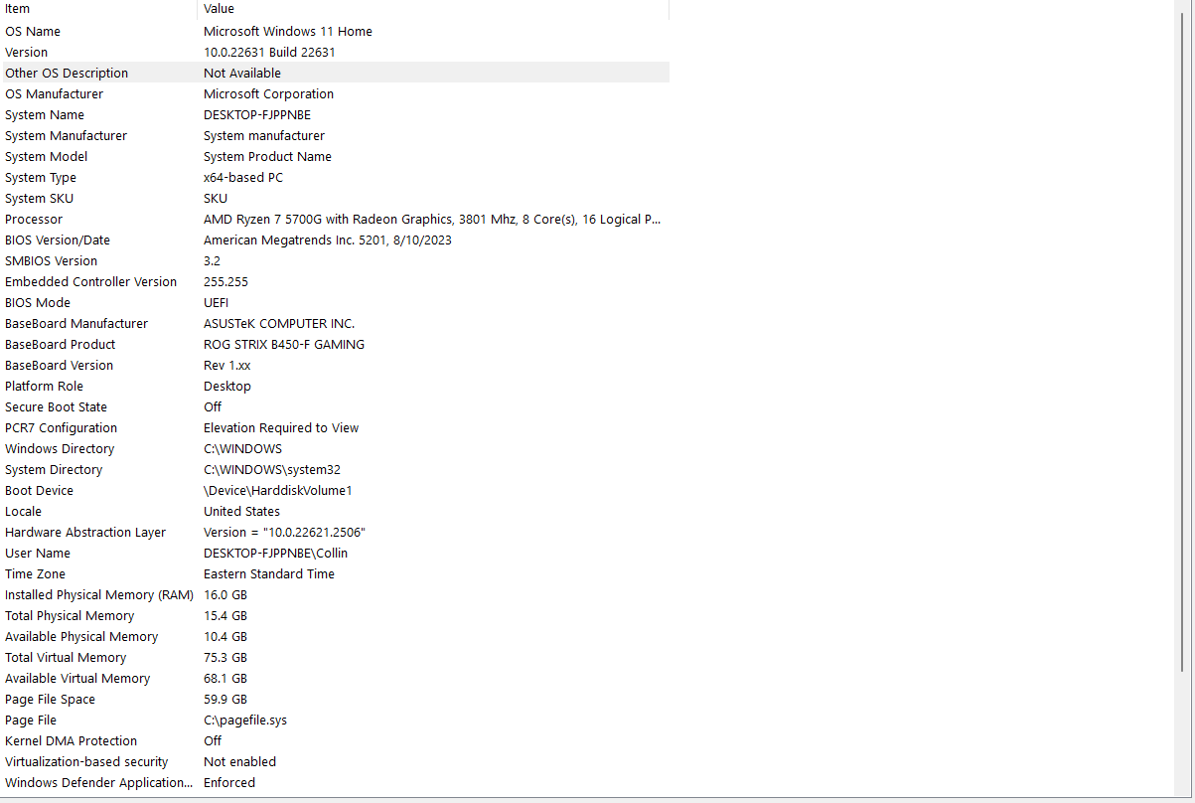
This is my computers system information.

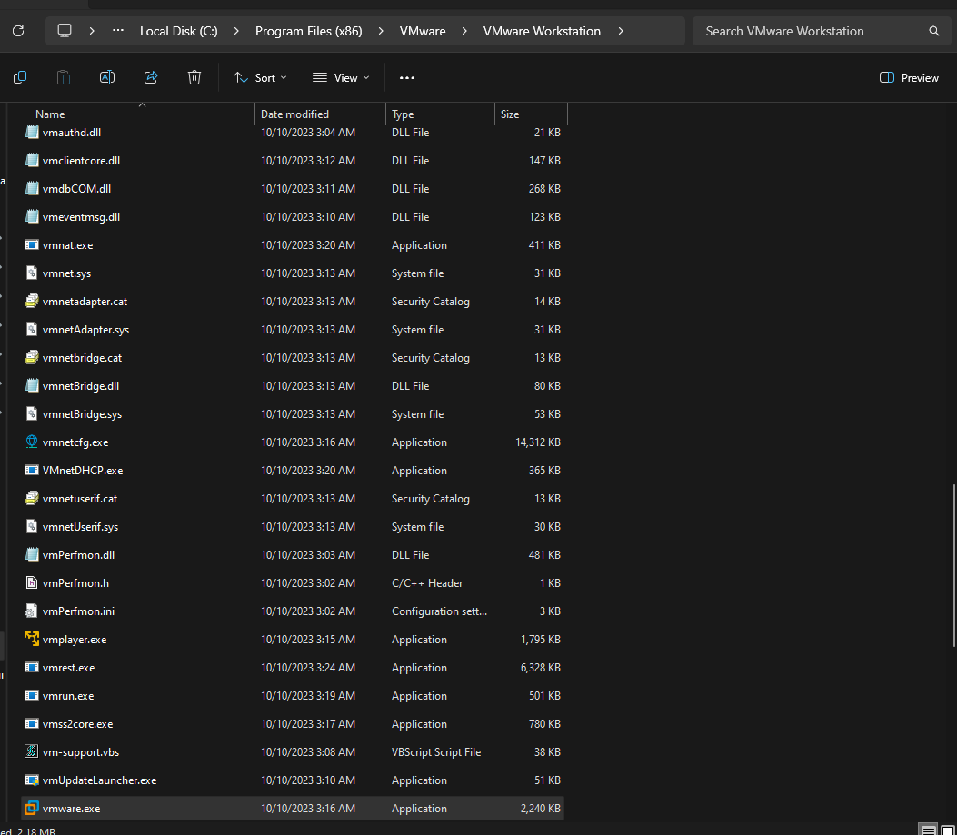

This shows the file location of the VMWare executable file.
This has been installed on an SSD in hopes of faster loading times.

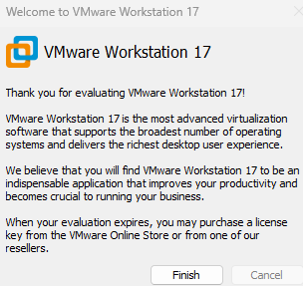
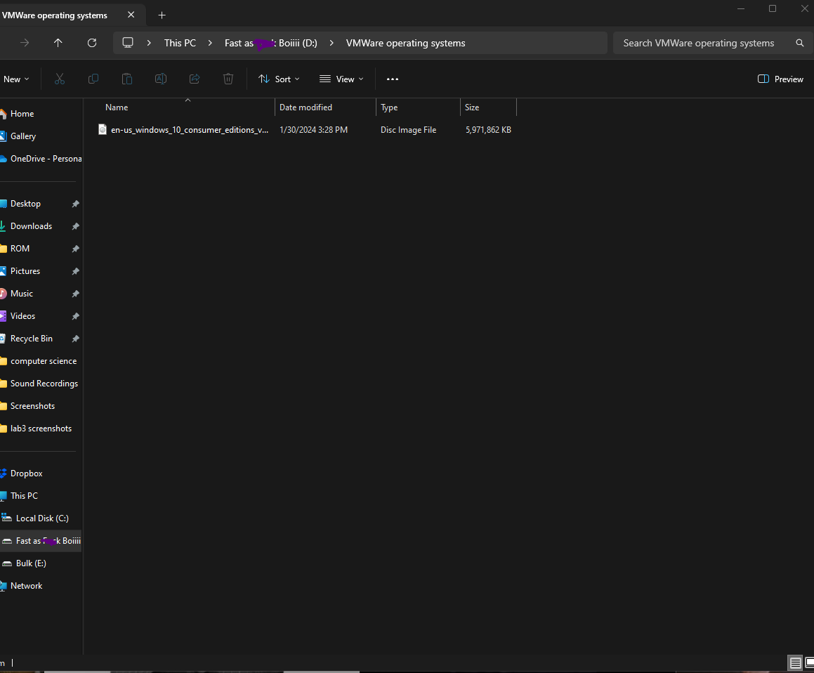
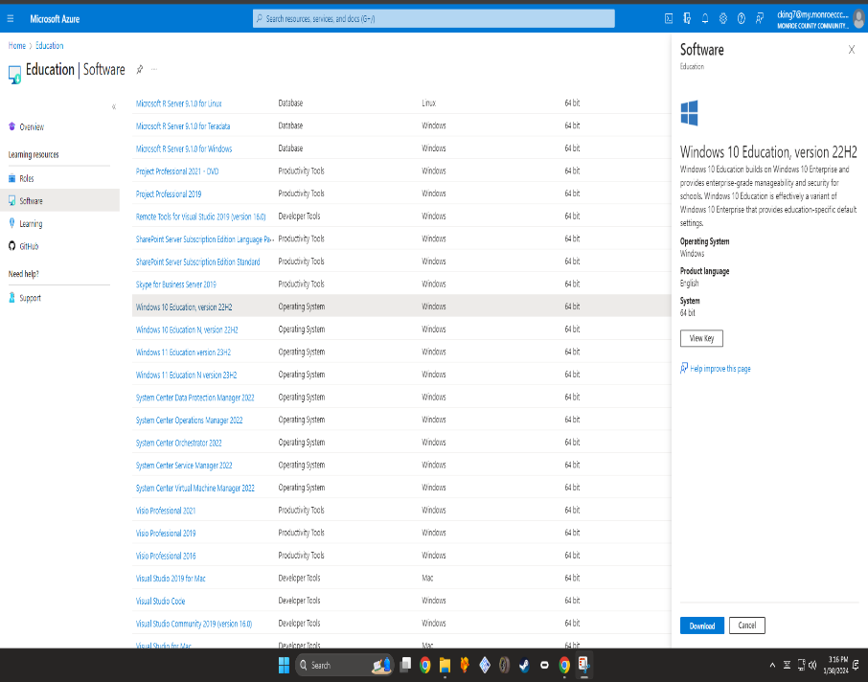
This shows me on Azure. Ive found the Windows 10 education version 22h2.
Ive gotten my product key and documented it for activation during installation.

I’ve installed the windows 10 .ISO file.
Also installed on an SSD hoping for faster loading or installation times.

Activated VMware with the key from email.

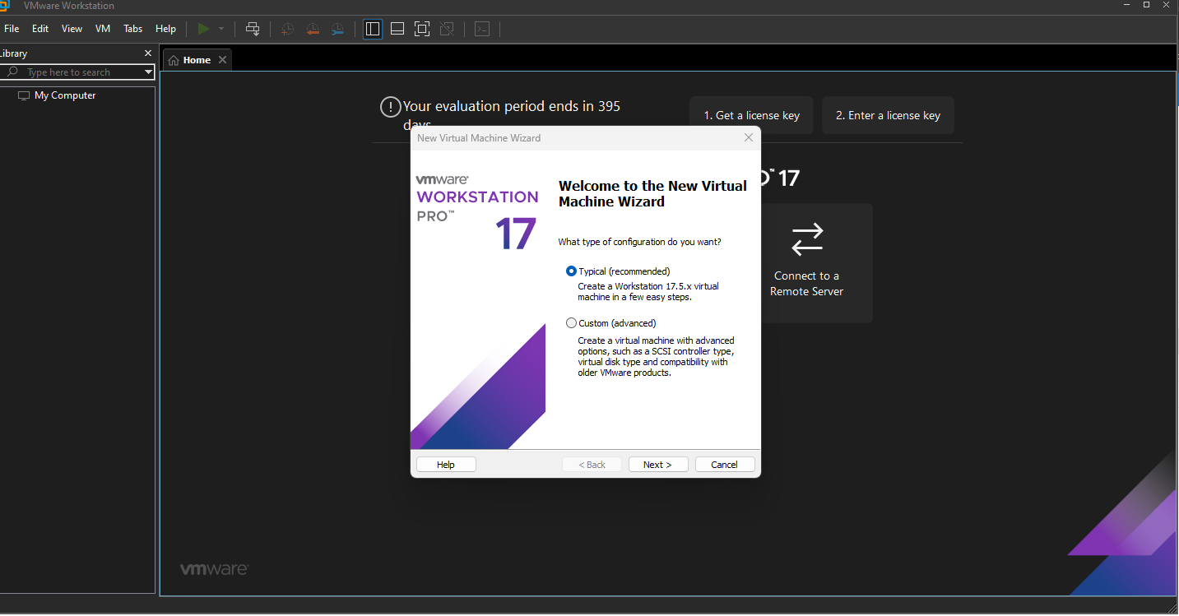

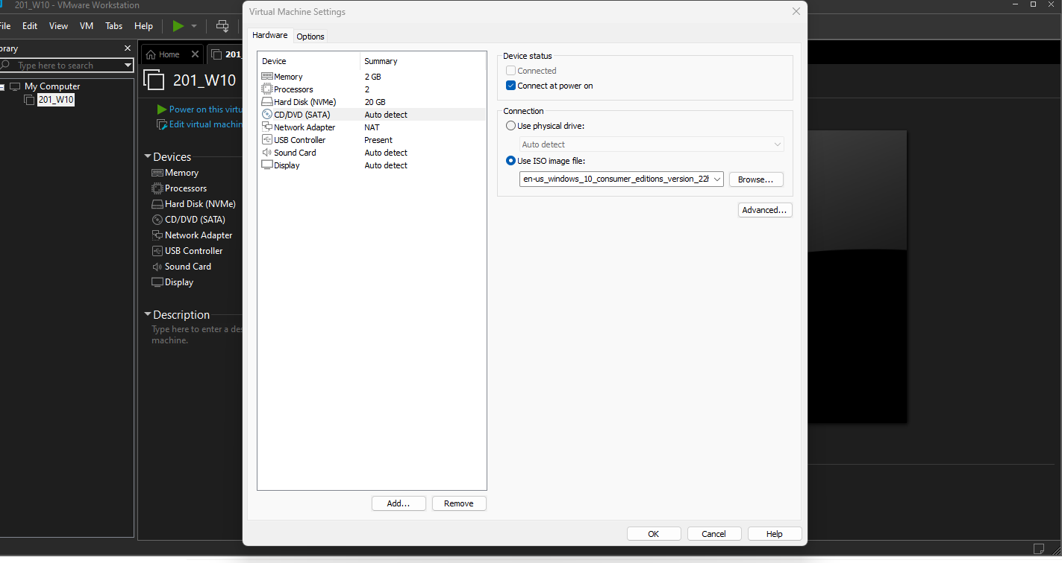
Started to create a new virtual machine with the typical installation option.

Selecting the ISO image in the CD/DVD option to boot the windows installer.
Showing virtual machine hardware.

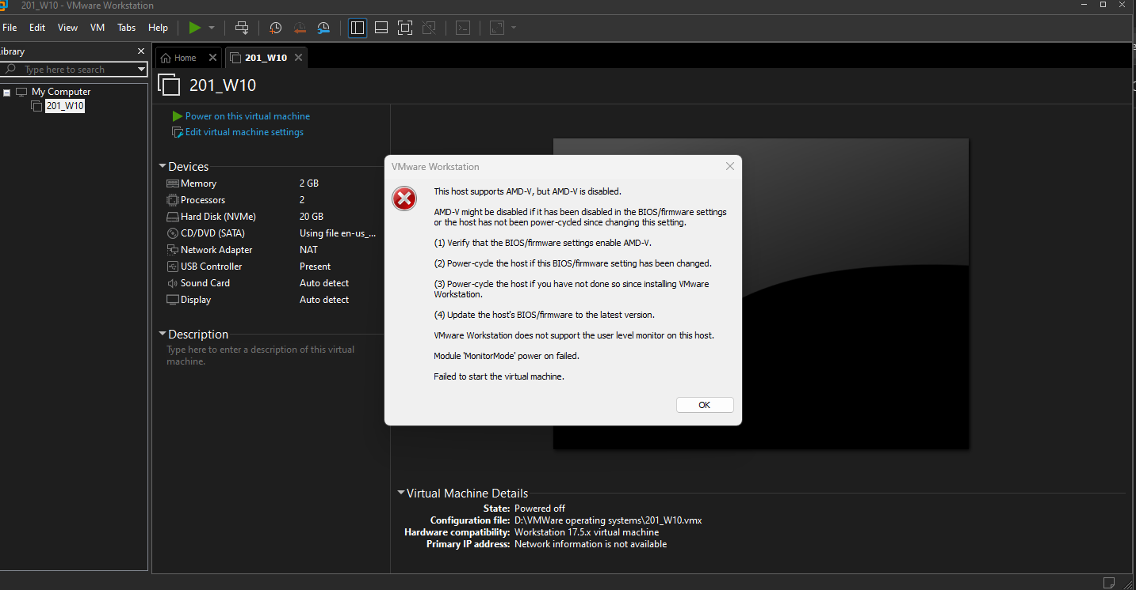
Got this error trying to run the machine. I had to go into motherboard BIOS to enable CPU Virtualization. AMD CPUS have it off as default for some CPUs, so I had to activate it. Very simple as the ASUS BIOS screen is simple to navigate.
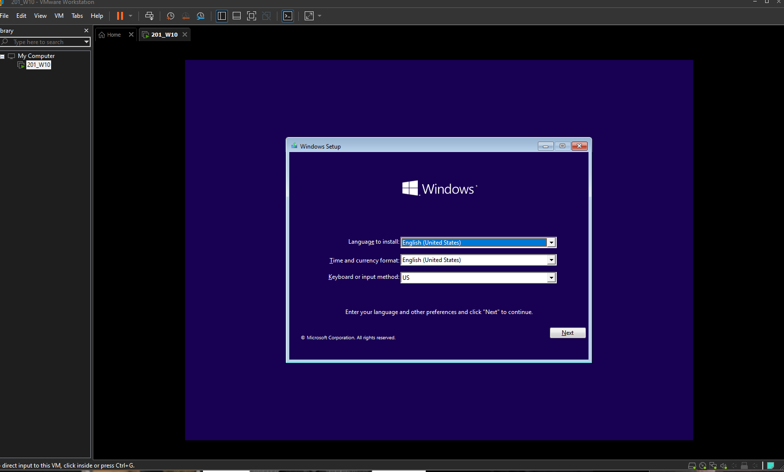

Starting the windows installation process on the virtual machine. No options changed on screen.

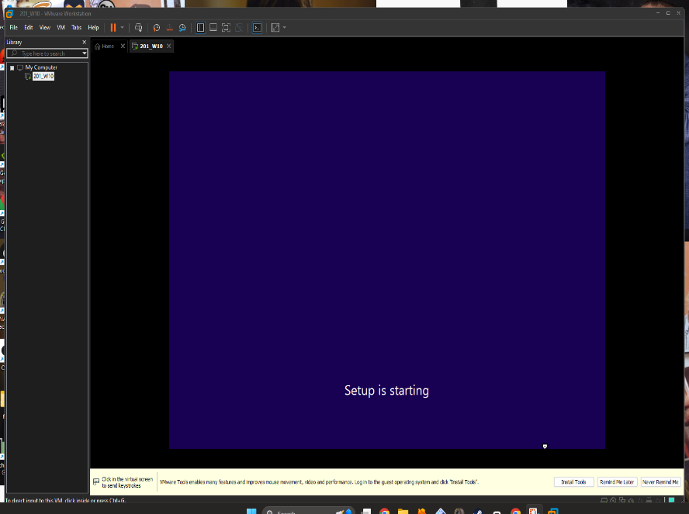
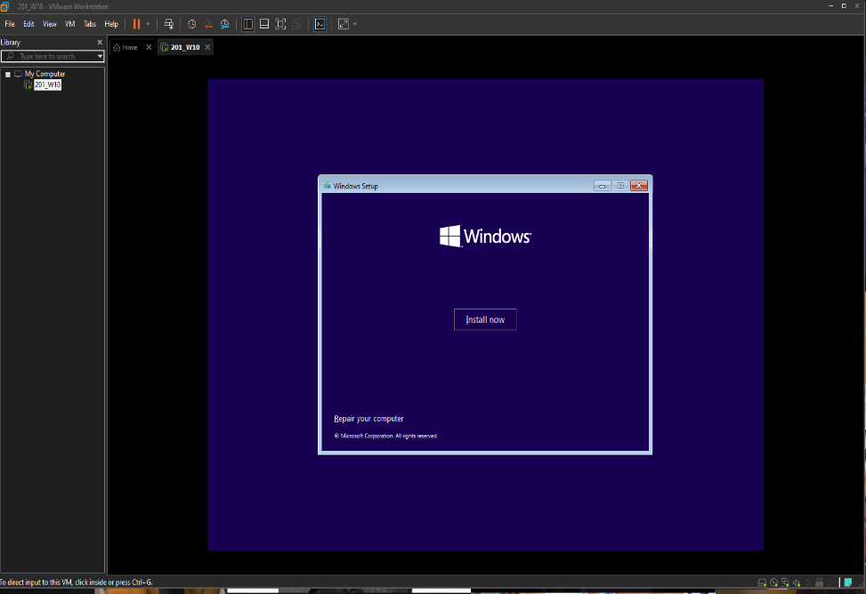
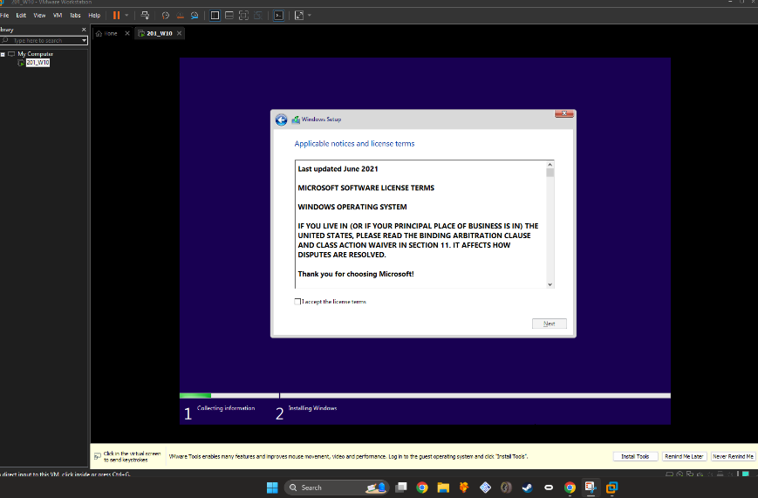
The process has started. Time to wait. Pretty sure around this time you played music in the windows 10 install video, and it was really loud because I had to turn it up as it was kind of hard to hear you. It scared me pretty good.
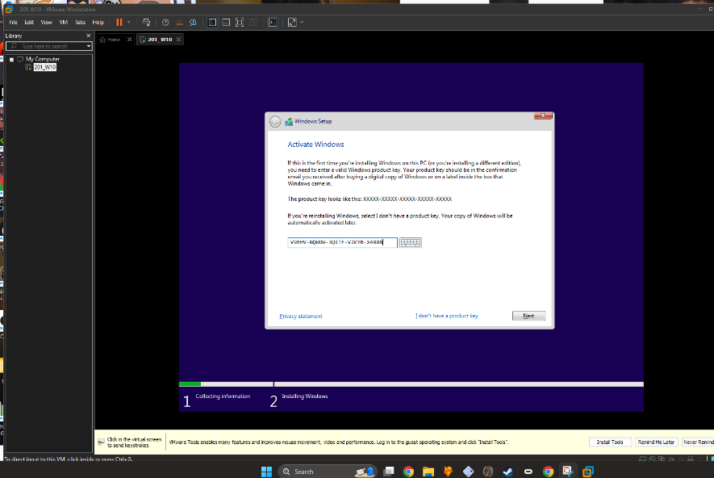
I typed in my license key and accepted the terms and conditions.

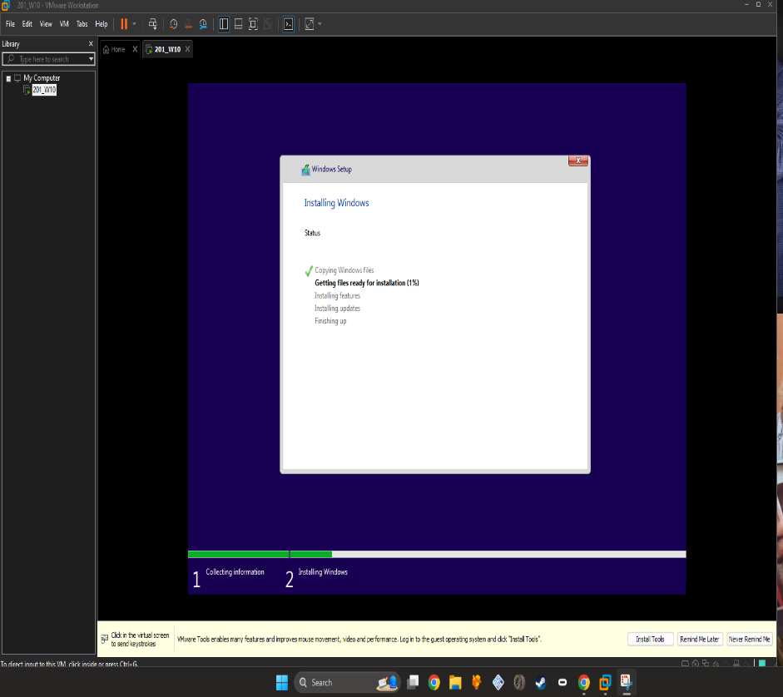
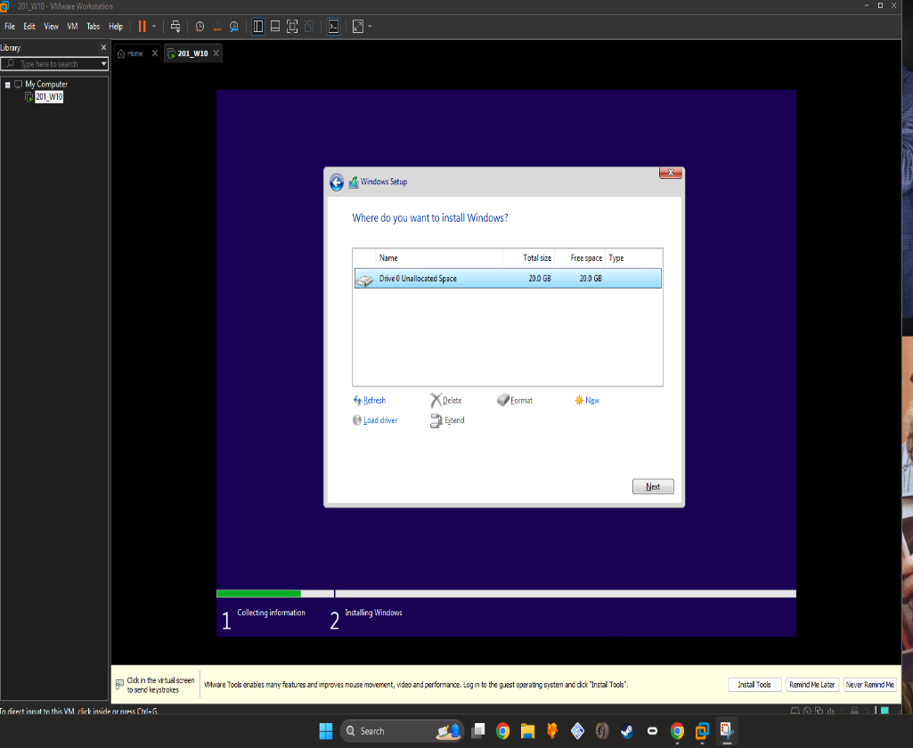

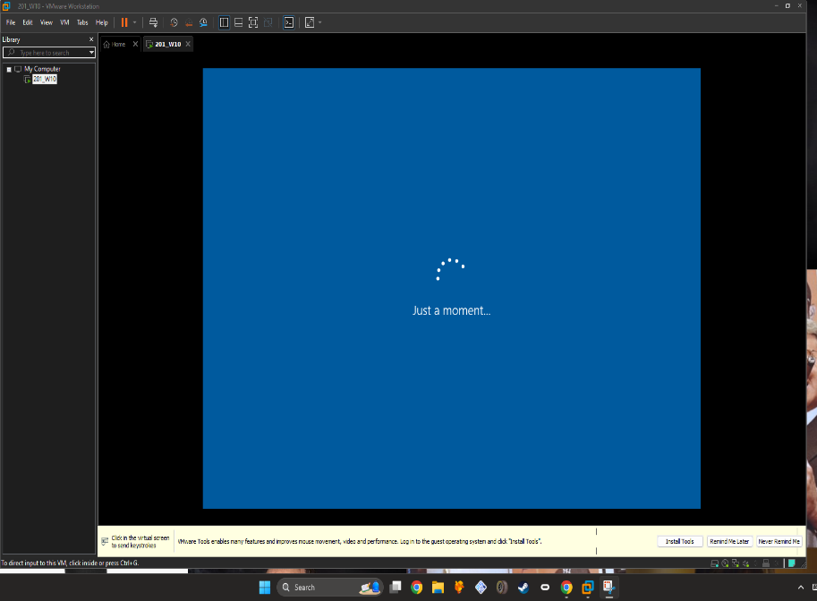
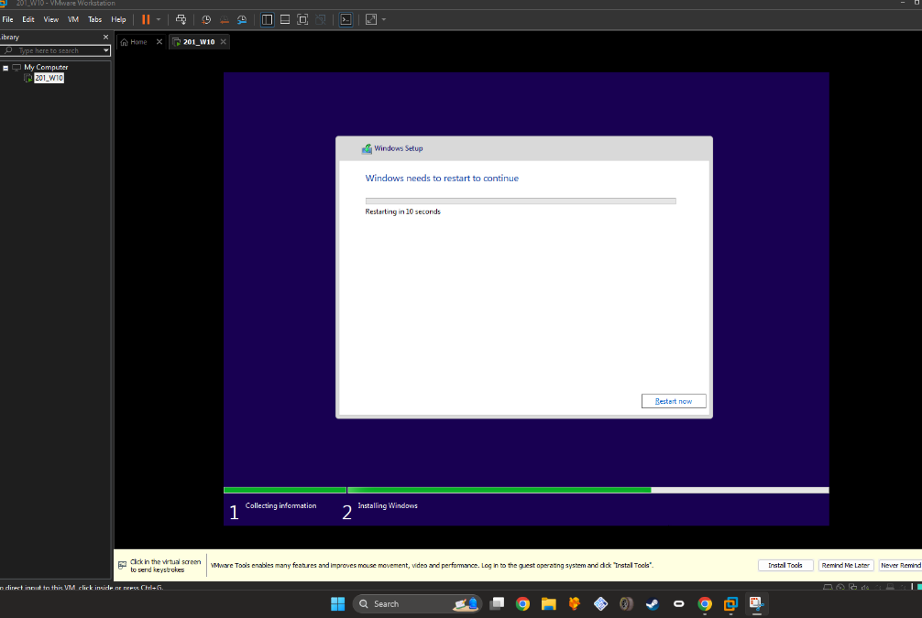
Selected the 20 GB hard drive to install windows on. Then I waited for windows to get the files ready.

Windows finished the process, waiting for restart. I clicked on restart now.
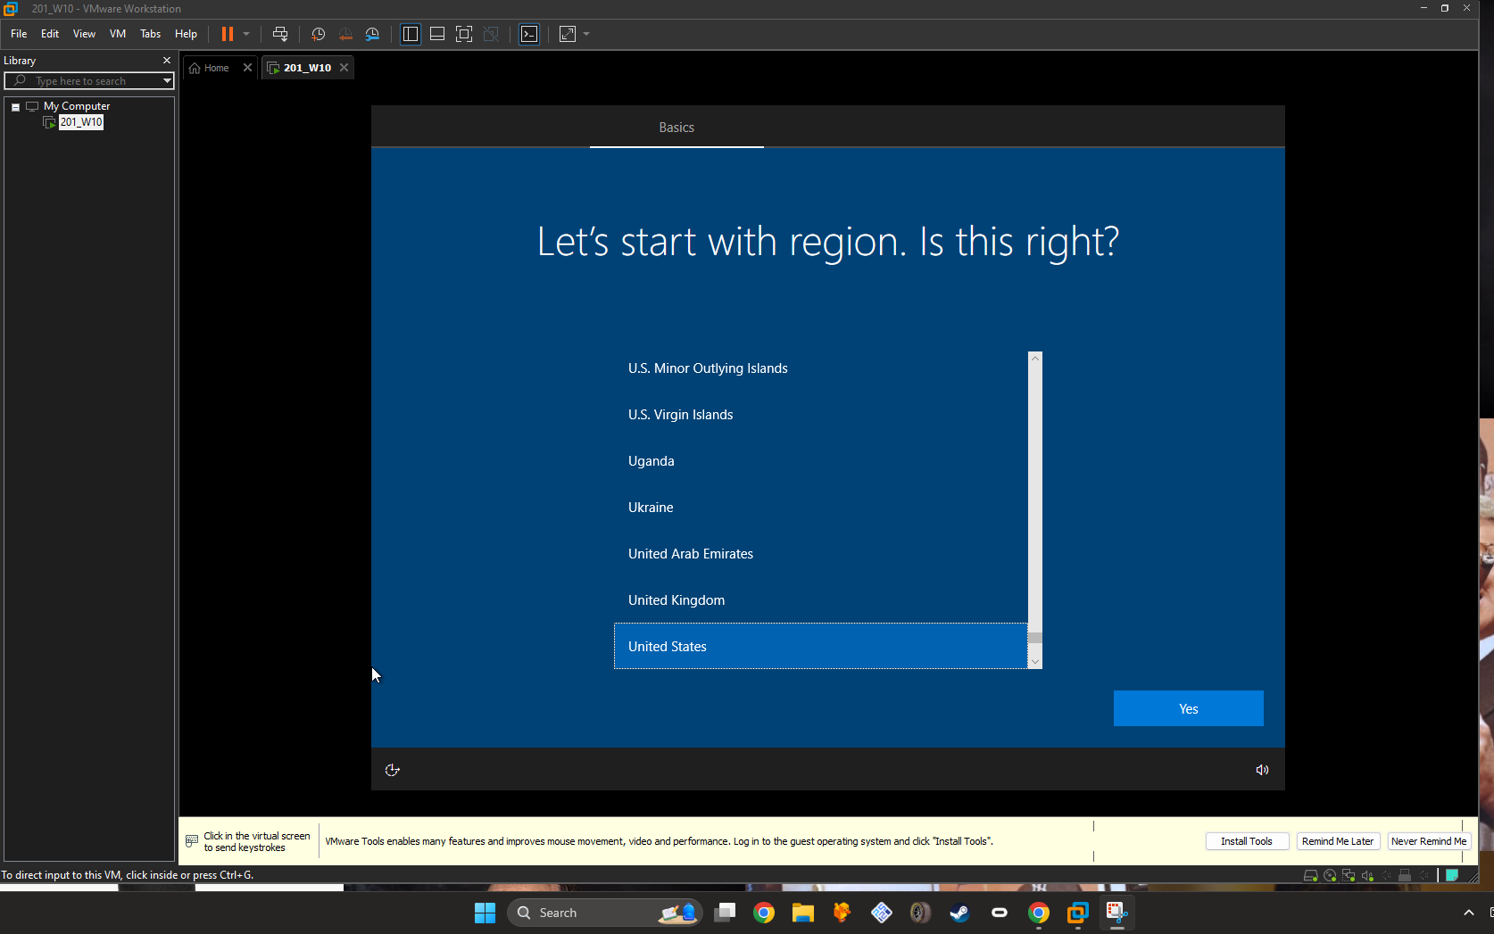
Windows first time bootup screen. I selected United States, English keyboard, and no secondary keyboard.

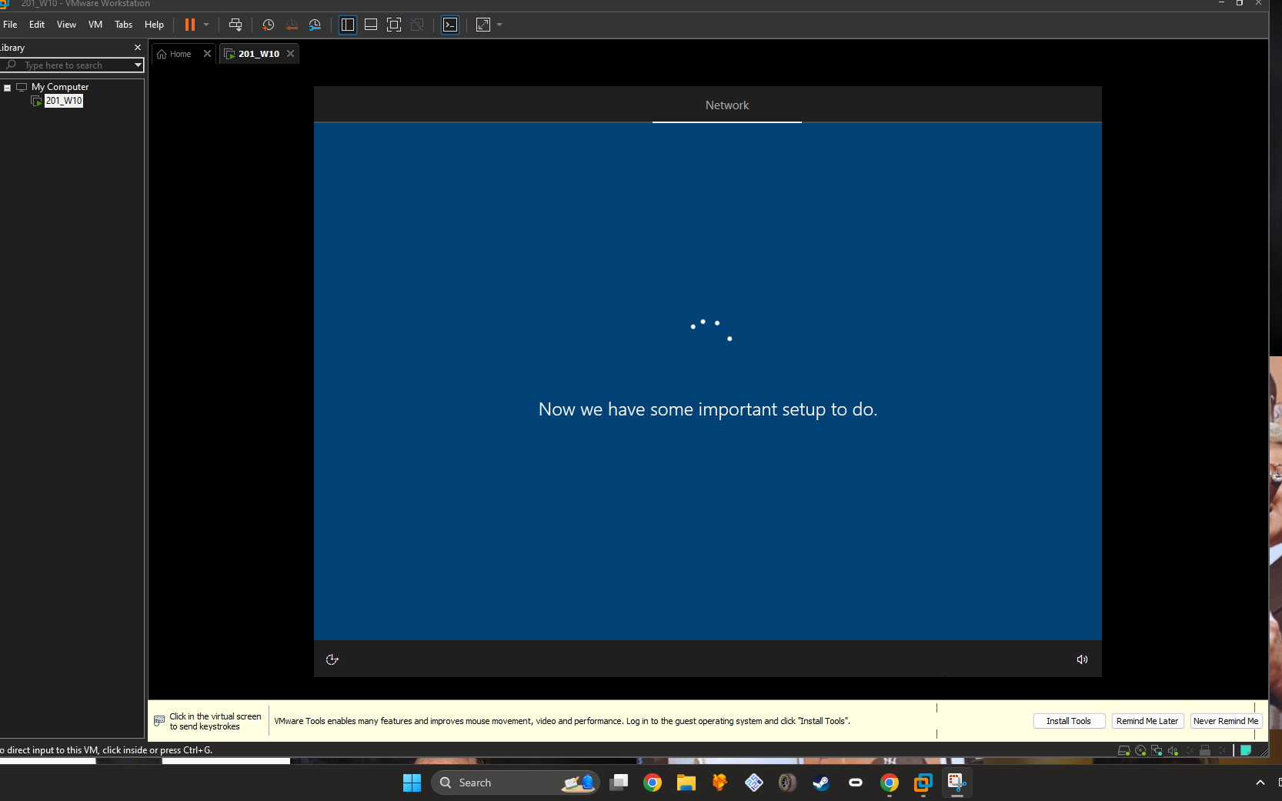

After those selections I had to wait a little bit more for a setup to complete.

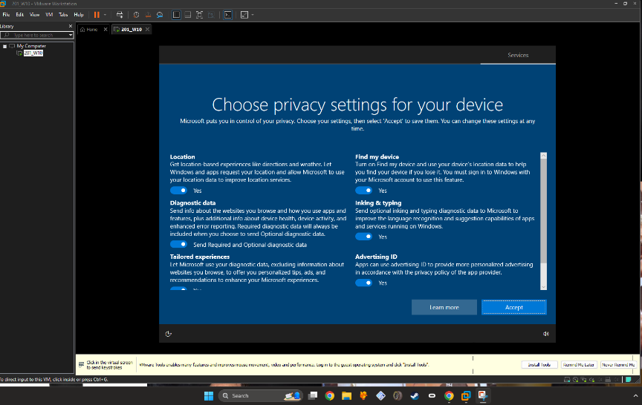
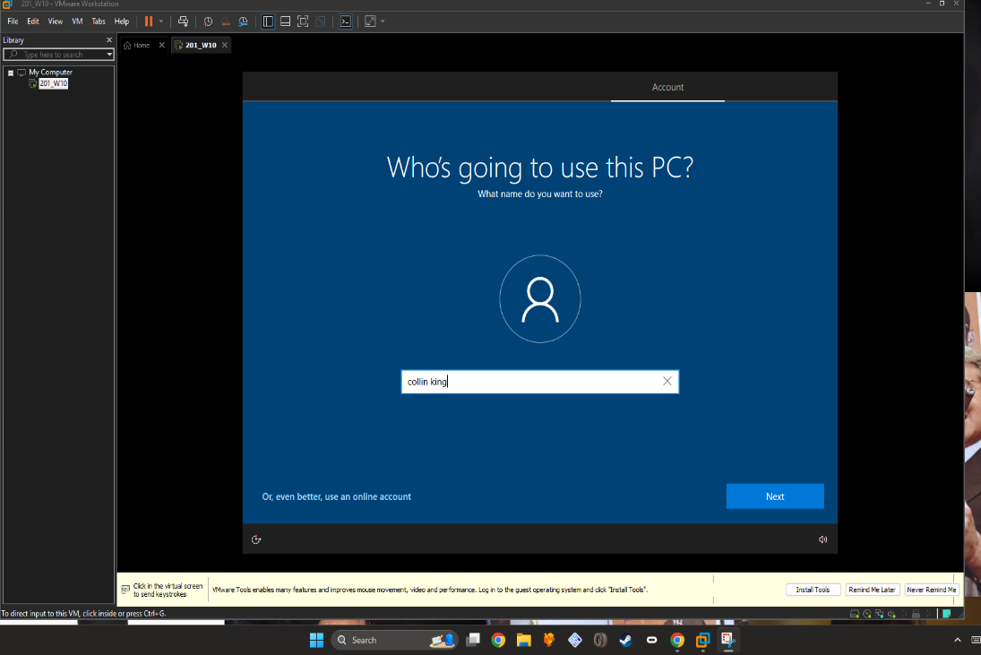
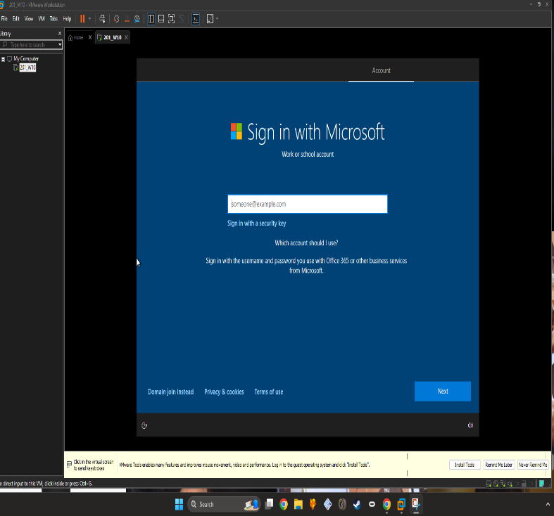
They tried making me use an online account, I clicked domain join instead. Then put my first and last name as my username and I picked a password that’s easy for me but no one else.
I changed no options on the privacy menu.
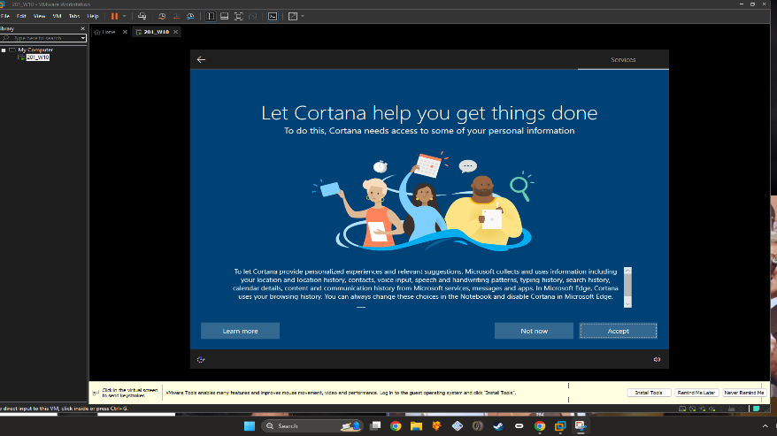

I’ve declined Cortana’s offer. I don’t even use it on my main computer.
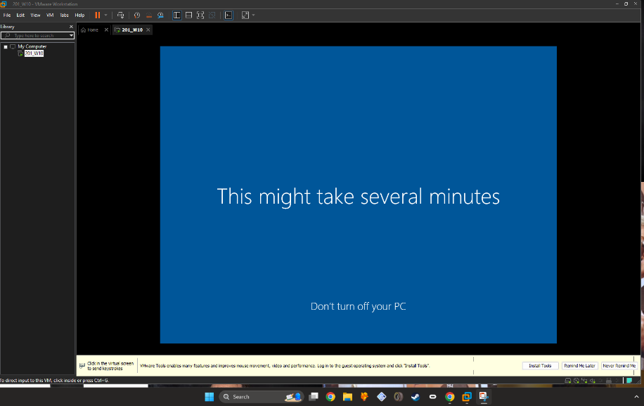
More music from the video as we waited.

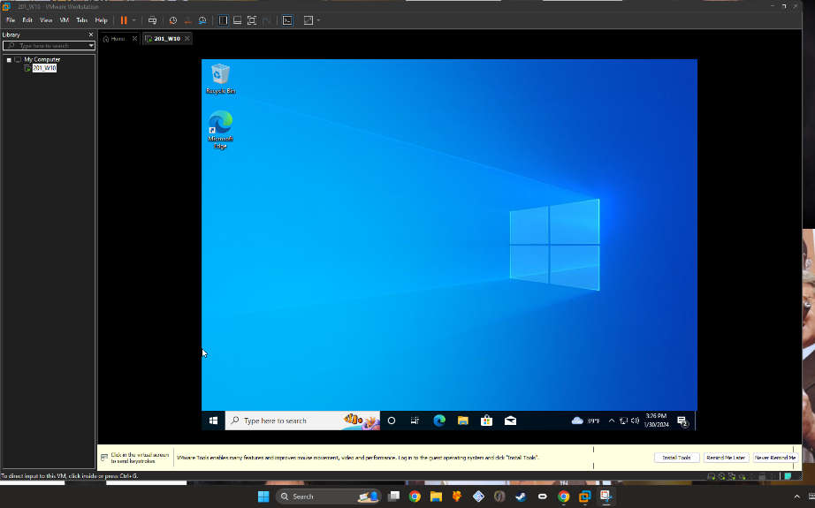

Windows 10 installation finished! I now have a fully functional virtual machine from VMWare.

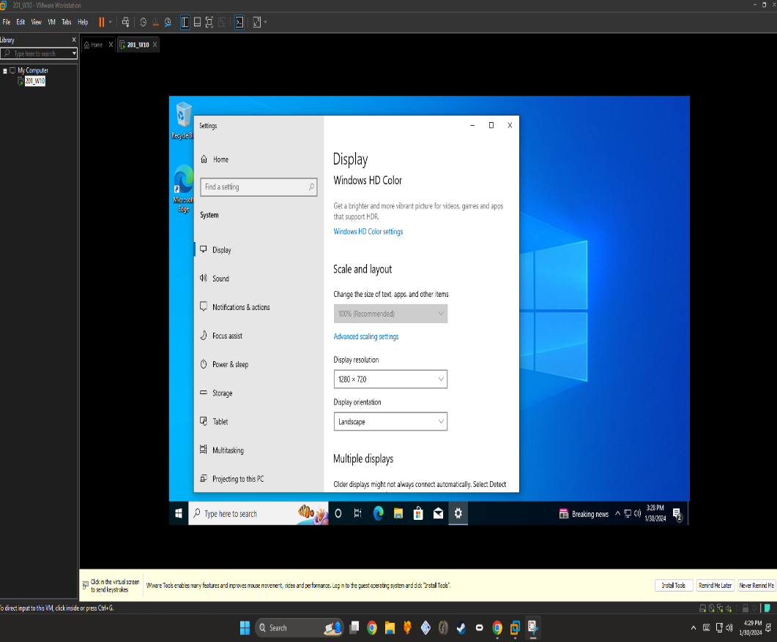

Changed the display resolution to 1280x720, reason is because it’s the option I can see the most without having to move the VMware window.

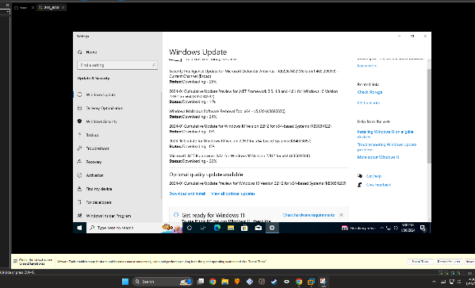
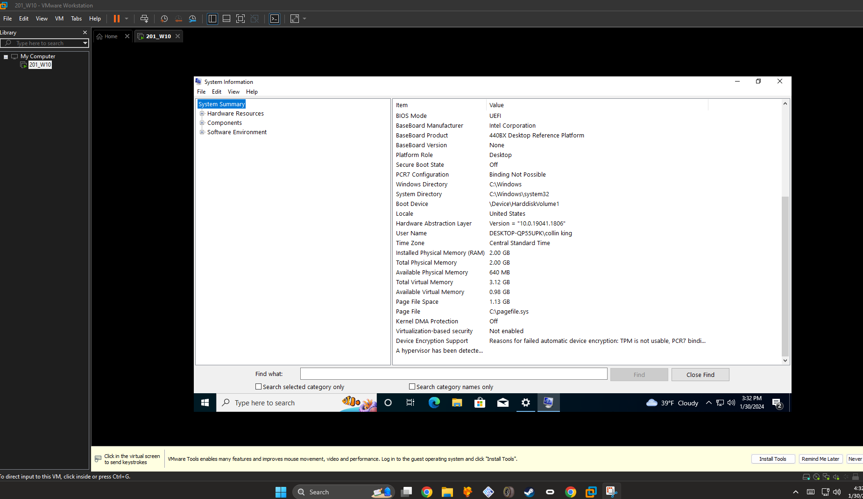
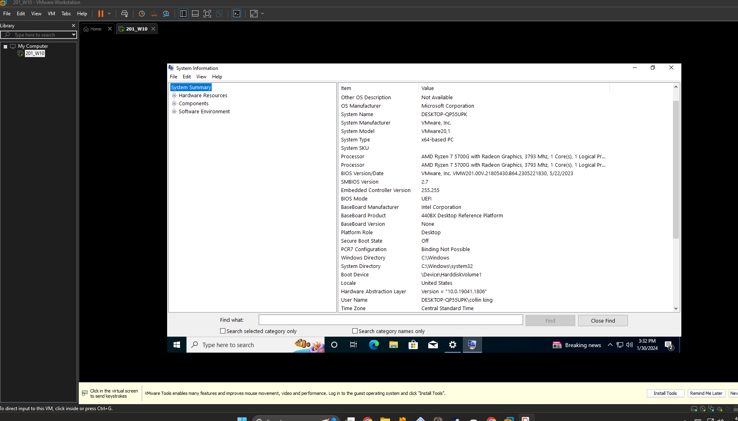
Virtual machine system information.

